Automated Network Request Management in ServiceNow
Idea Prioritization
Date | 09 September 2026
Student Name | Banna Madhuri
Project Name | Automated Network Request Management in ServiceNow
Maximum Marks

Idea Prioritization
The prioritization below focuses on the core components of the Automated Network Request Management project — the Service Catalog submission, the automated flow, the approval process, and the underlying data and security model. Each component is rated High or Medium based on its importance to the project's business objective, its feasibility, its role in automation, and its dependency on other components.
Idea Group / Feature | Purpose in Project | Priority | Reason for Priority
Network Request Service Catalog | Service Catalog item (Category: Network) through which end users submit a network request for a new or existing connection. | High | Serves as the single entry point for all network requests and directly supports faster, more reliable service delivery for end users.
Network Request Form and Variables | Captures request details through variables such as Requested For, Mobile Number, Type of Connection, Existing ID, Total Amount, Mode of Payment, and Address, along with the Opened on Behalf Of variable set. | High | Captures the information required to process a request accurately and reduces manual effort and error at the point of submission.
Flow Designer Automation | Automates the request lifecycle using Get Catalog Variables, Create Record, Send Email, Ask for Approval, If/Else flow logic, and Update Record, triggered on catalog submission. | High | Delivers the end-to-end automation of the request lifecycle, which is the central business objective of the project.
Approval Routing | Ask for Approval step and Approval Request related list route each submitted request for approval, with Approval Status maintained on the Network Database record. | High | Enforces a standardized, auditable approval process before fulfilment, meeting compliance needs and approver expectations.
Network Database Record Creation | Create Record step generates a Network Database record capturing Database Number, Assignment To, Mobile Number, Total Amount, Mode of Payment, Type of Connection, Customer Address, Approval Status, and Requested For. | High | Establishes the centralized record that IT Admins and the Network Fulfilment Team rely on to execute and track network changes.
Dynamic Form Behaviour | Catalog UI Policy displays the Existing ID field only when Type of Connection is set to Existing. | Medium | Improves data accuracy for existing-connection requests but is a refinement built on top of the core form rather than a standalone requirement.
Email Notifications | Send Email step within the flow communicates request progress to relevant stakeholders. | Medium | Improves visibility and communication, but the request can still progress through the flow without it.
Request Tracking / Status Visibility | Approval Status field on the Network Database record allows the current standing of a request to be viewed. | Medium | Adds visibility for requesters and approvers, but depends on the Network Database record already being created.
Access Control | Default ACLs and Access Control Rules on the Network Database table restrict read/write access to sensitive fields based on role. | Medium | Protects sensitive fields in line with IT and security policy, and depends on the Network Database table already being in place.
Validation and Testing | Mandatory fields, auto-populate logic, and approval state validation are confirmed through unit testing, end-to-end simulation, and User Acceptance Testing. | Medium | Confirms the reliability of the automation and data before go-live, and is carried out once the core features are built.

Prioritization Overview
The card view below summarizes each project component alongside its assigned priority level.
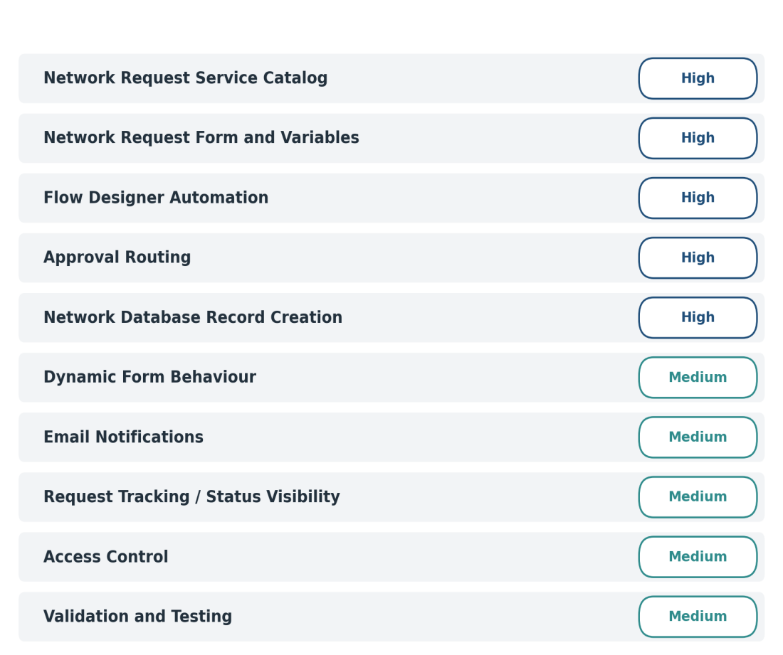
Figure 1: Prioritized representation of the Automated Network Request Management components.

